RESUME

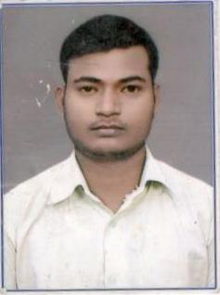
AMAN KUMAR

Address :
Vill – Aswar Tarapur,
Fatehpur - 212664
Mobile : 9936946111

Objective :
I want to work in an organisation where I can use my skills and enjoy working.

Educational Qualification
DEGREE | COLLEGE | UNIVERSITY / BOARD | Year | Percentage
High School | Adarsh Gandhi Ucchtar Mad Vidhalaya | UP Board | 2010 | 62
Intermediate | M C R G Inter College Deviganj fatehpur | UP Board | 2012 | 66
Bachelor of Science  (Maths) | Abhay Pratap Singh Degree Fatehpur | CSJM University | 2015 | 52

Computer Litracy :
Diploma in Computer Application (DCA) .

Perosnal Details
Date of Birth : Dec 08, 1995
Fathers Name : Shri Ram Kumar
Mother Name : Shakuntala Devi
Language : Hindi, English
Nationality : Indian
Marital Status : Unmarried
Hobbies : Playing Volleyball

Palce
Date : Aman Kumar

